**TELECOM CUSTOMER CHURN PREDICTOR USING AUTO AI**

|  |  |
| --- | --- |
|  |  |
| **S NO** | **TOPICS** |
| **1** | **INTRODUCTION** |
| **2** | **LITERATURE SURVEY**  **Existing problem**  **Proposed Solution** |
| **3** | **BLOCK DIAGRAM** |
| **4** | **EXPERIMENTAL INVESTIGATIONS**  **Collecting Dataset**  **IBM CLOUD Account**  **Login**  **Create Watson Studio platform**  **Add Machine Learning service**  **Model Building**  **Create Project**  **Select pipeline**  **Test Model**  **Application Building**  **Create NodeRed service**  **Go to pallete and add dashboard nodes**  **Build ui with nodered** |
| **5** | **ADVANTAGES AND DISADVANTAGES** |
| **6** | **FUTURE SCOPE** |
| **7** | **BIBLOGRAPLY** |

**Introduction to IBM Watson**

Watson is a [question answering](https://en.wikipedia.org/wiki/Question_answering) computer system capable of answering questions posed in [natural language](https://en.wikipedia.org/wiki/Natural_language), developed in [IBM](https://en.wikipedia.org/wiki/IBM)'s DeepQA project by a research team led by [principal investigator](https://en.wikipedia.org/wiki/Principal_investigator) [David Ferrucci](https://en.wikipedia.org/wiki/David_Ferrucci). Watson was named after IBM's founder and first CEO, industrialist [Thomas J. Watson](https://en.wikipedia.org/wiki/Thomas_J._Watson).

The computer system was initially developed to answer questions on the [quiz show](https://en.wikipedia.org/wiki/Quiz_show) [*Jeopardy!*](https://en.wikipedia.org/wiki/Jeopardy!) and, in 2011, the Watson computer system competed on *Jeopardy!* against champions [Brad Rutter](https://en.wikipedia.org/wiki/Brad_Rutter) and [Ken Jennings](https://en.wikipedia.org/wiki/Ken_Jennings), winning the first place prize of $1 million.

In February 2013, IBM announced that Watson software system's first commercial application would be for [utilization management](https://en.wikipedia.org/wiki/Utilization_management) decisions in [lung cancer](https://en.wikipedia.org/wiki/Lung_cancer) treatment at [Memorial Sloan Kettering Cancer Center](https://en.wikipedia.org/wiki/Memorial_Sloan_Kettering_Cancer_Center), New York City, in conjunction with WellPoint (now [Anthem](https://en.wikipedia.org/wiki/Anthem_(company))). In 2013, Manoj Saxena, IBM Watson's business chief said that 90% of nurses in the field who use Watson now follow its guidance.

**LITERATURE SURVEY**

**CHURN PREDICTOR INTRODUCTION**

**Customer churn is a major problem and one of the most important concerns for large companies. Due to the direct effect on the revenues of the companies, especially in the telecom field, companies are seeking to develop means to predict potential customer to churn. Therefore, finding factors that increase customer churn is important to take necessary actions to reduce this churn. Churn prediction helps in identifying**

**those customers who are likely to leave a company. The main contribution of our work is to develop a churn prediction model which assists telecom operators to predict customers who are most likely subject to churn. The model developed in this work uses machine learning techniques on IBM platform and builds a new way of features’ engineering and selection.**

**Solution:**

**Telecommunication industry always suffers from a very high churn rates when one industry offers a better plan than the previous there is a high possibility of the customer churning from the present due to a better plan in such a scenario it is very difficult to avoid losses but through prediction we can keep it to a minimal level. We are building a Machine Learning model to predict the customer churn using IBM Watson AutoAI Machine Learning Service. The model is deployed on IBM cloud to get scoring end point which can be used as API in mobile app or web app building. We are developing a web application which is built using node red service. We make use of the scoring end point to give user input values to the deployed model.**  
**The model prediction is then showcased on User Interface.**

BLOCK DIAGRAM

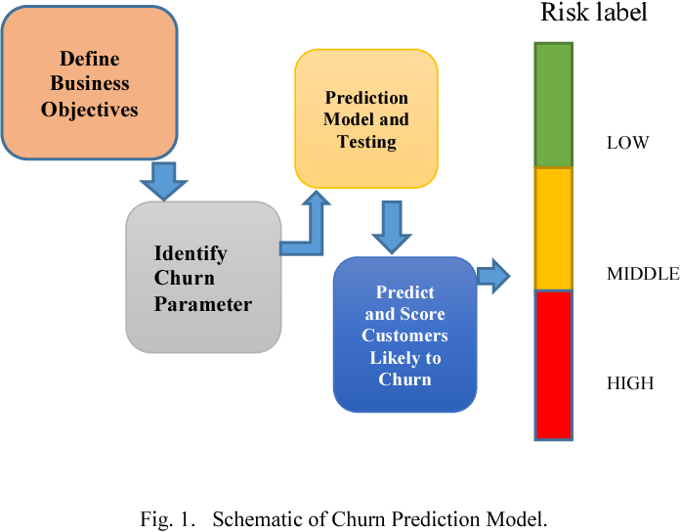

DATASET

STEP 1 - Collection of dataset

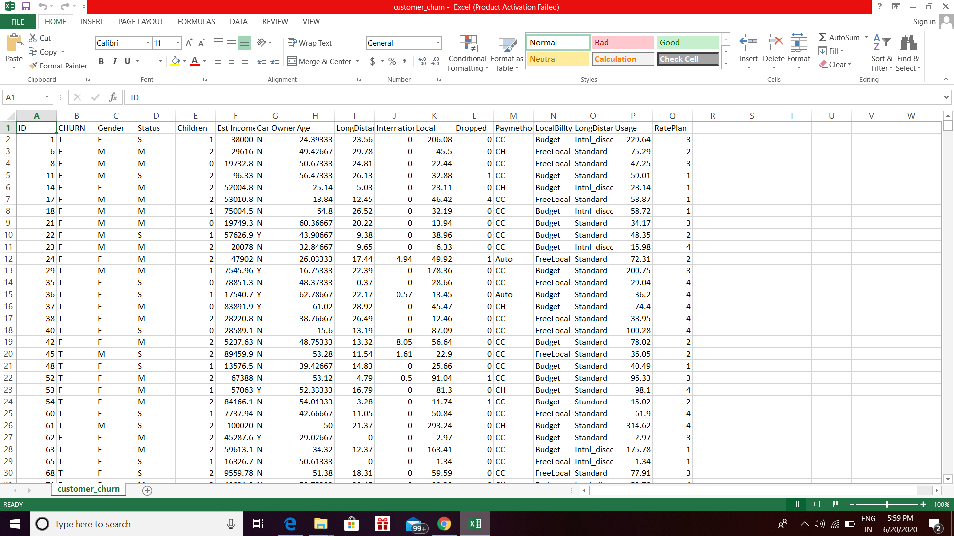

STEP 2- Refine or Preprocess Dataset

Dataset can be downloaded from many platforms like kaggel. It can olso be created by our own. After getting appropriate dataset we have to analyze to preprocess it to get our predictions.

This is the dataset I have used. It contains about 17 colums and 1500 rows.

**IBM CLOUD Account**

**STEP 1- Register to make an ibm account**

**Link for registration**----<https://cloud.ibm.com/registration>

**STEP 2 - LOGIN**

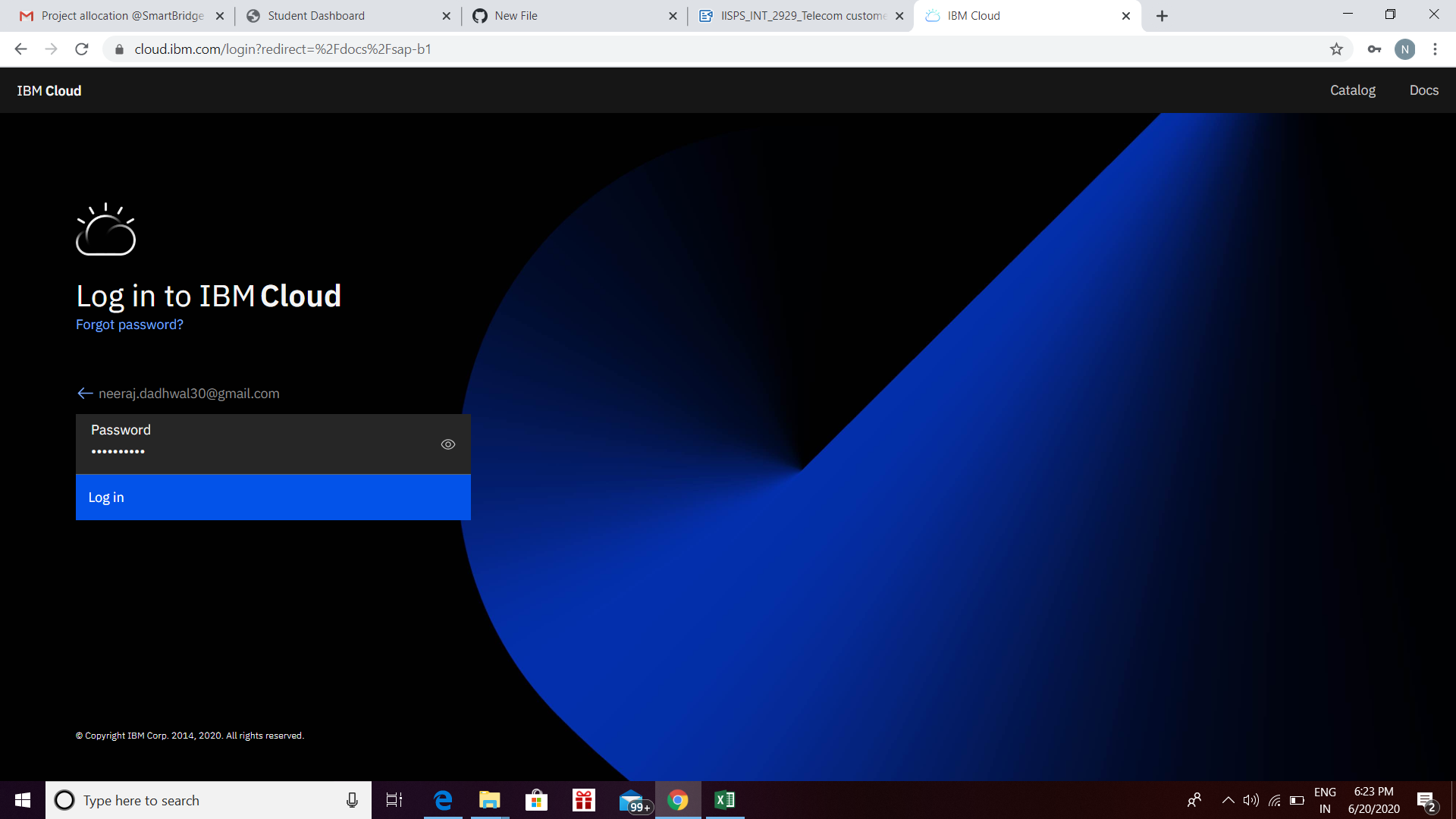

**STEP 3 - Create a watson studio platform and add a machine learning service to it.**

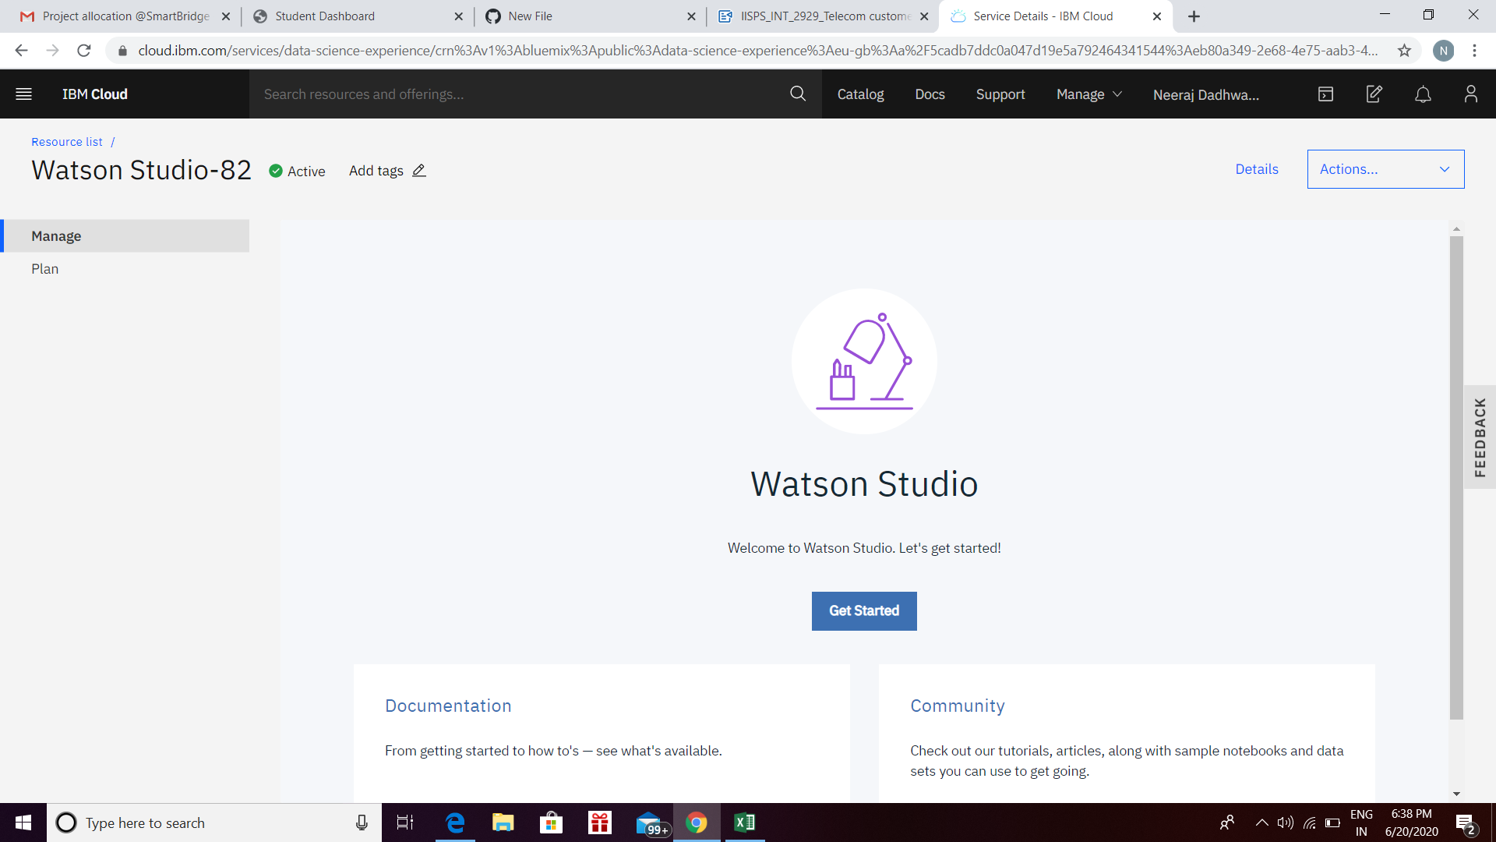

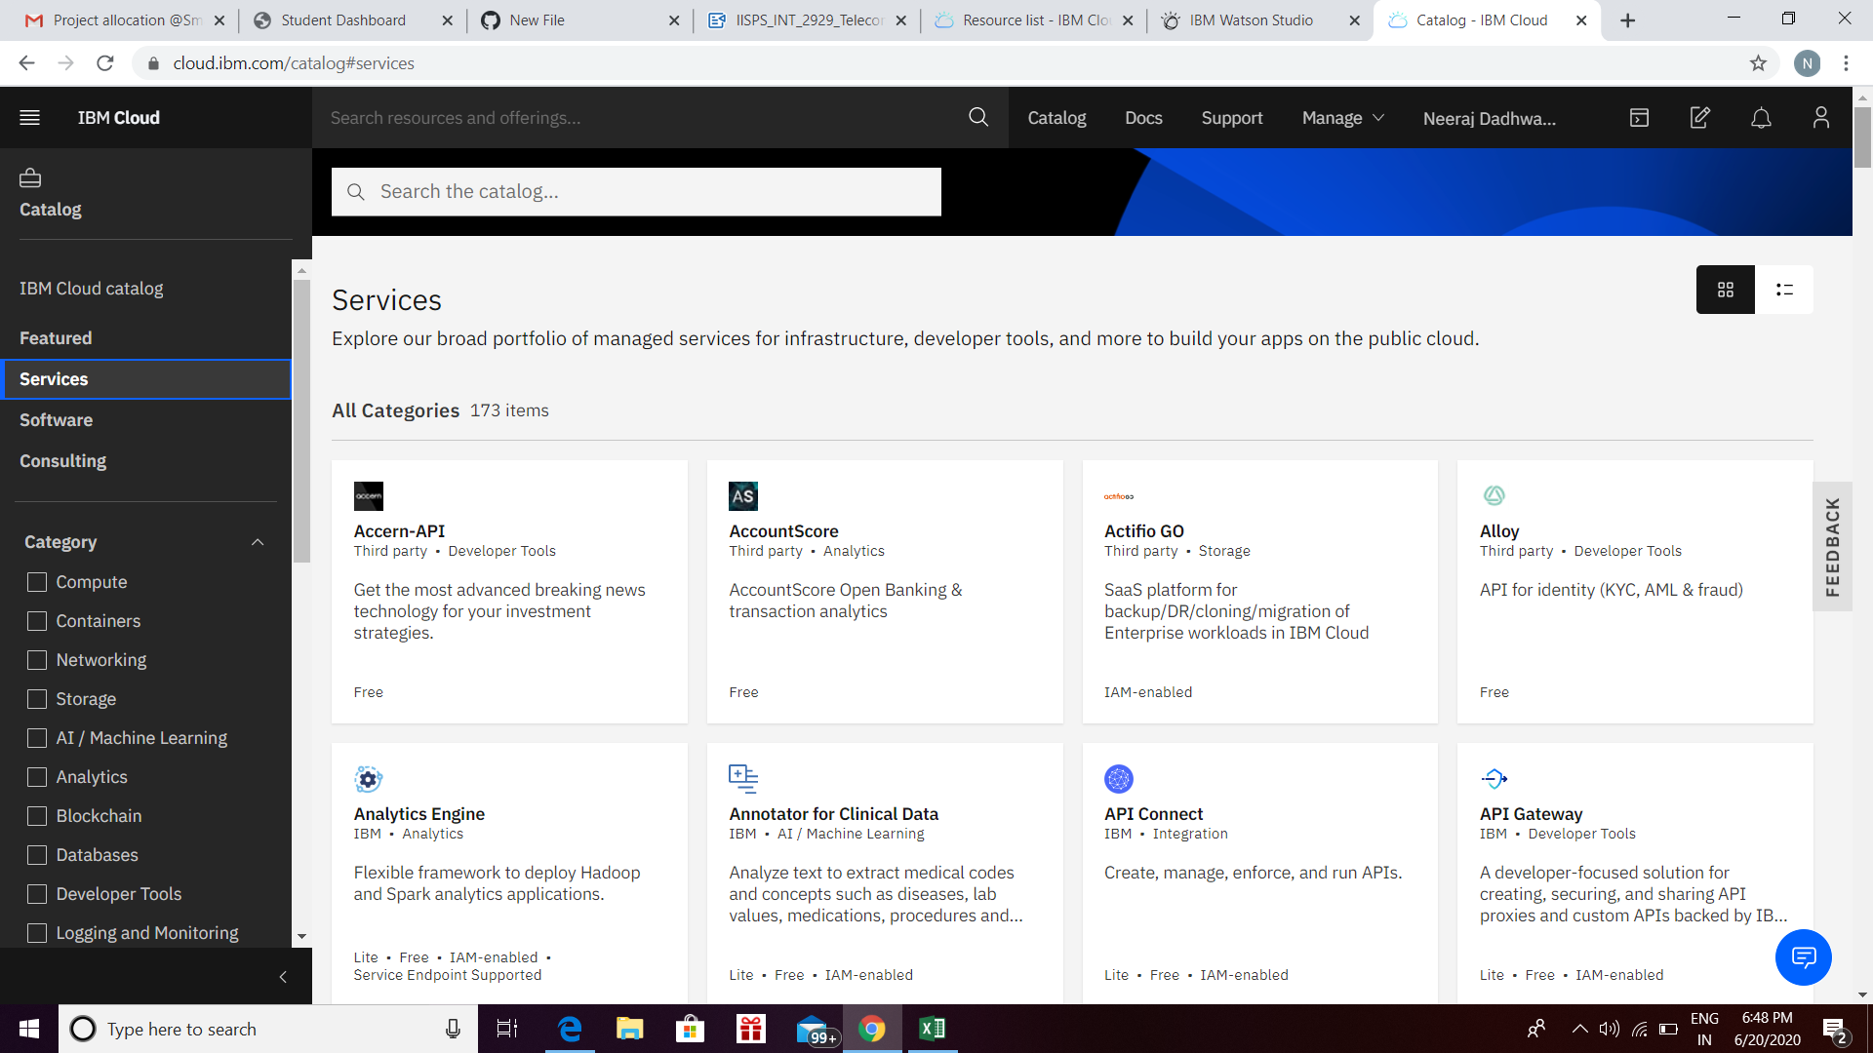

**MODEL BUILDING**

**STEP 1- Create project using watson platform and add auto ai in add projects**

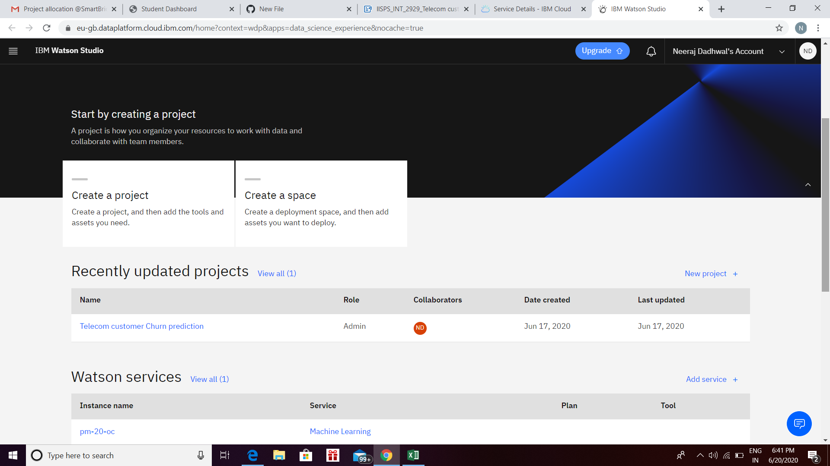

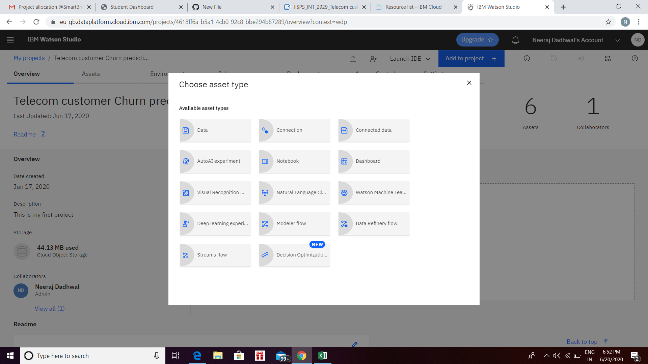

**STEP 2- Import Dataset**

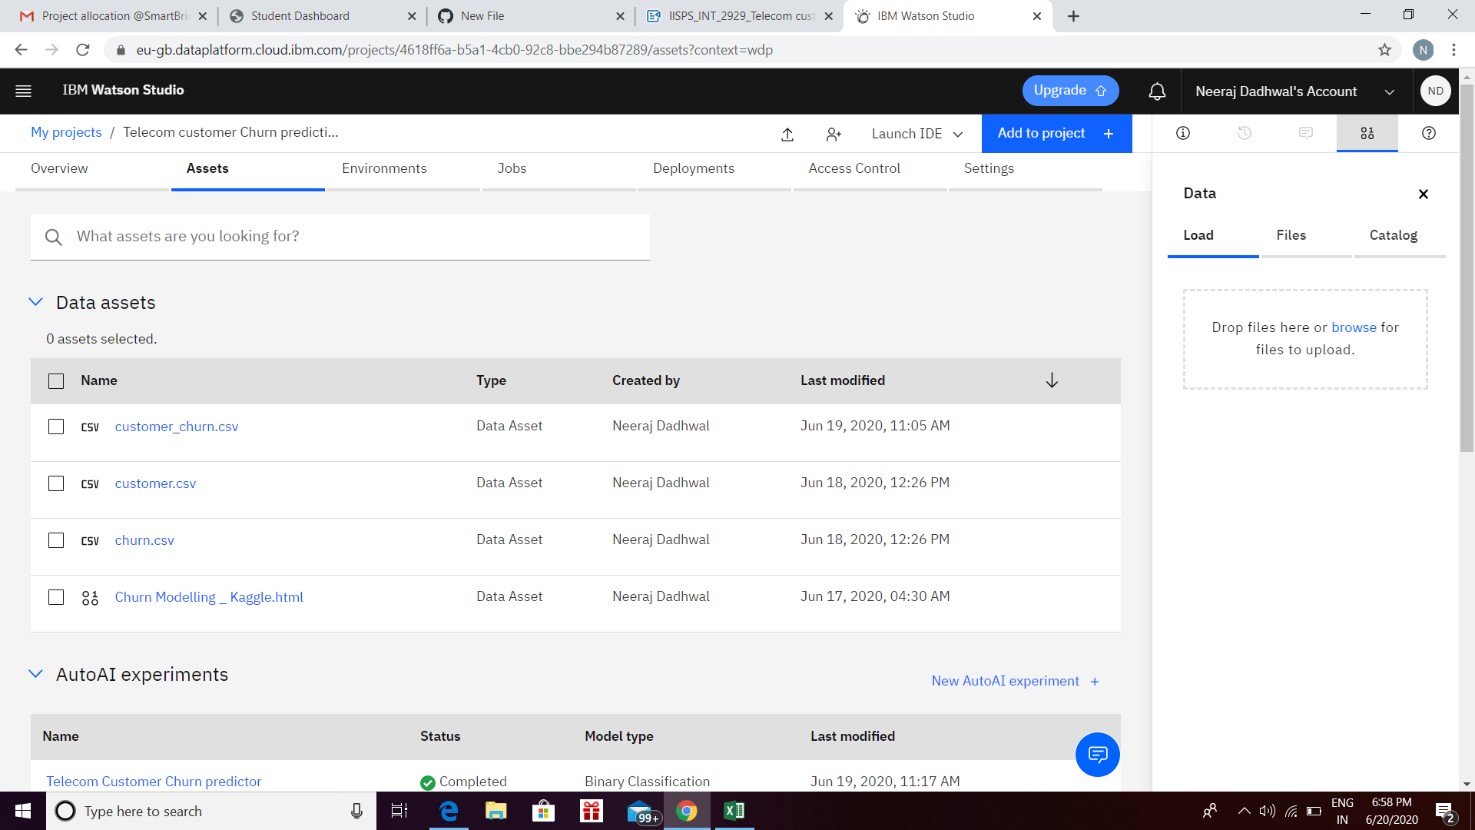

We need to import or add the data in csv form which works as an asset for the model.

**STEP 3** - **Run the model and pick the best pipeline for better accuracy.**

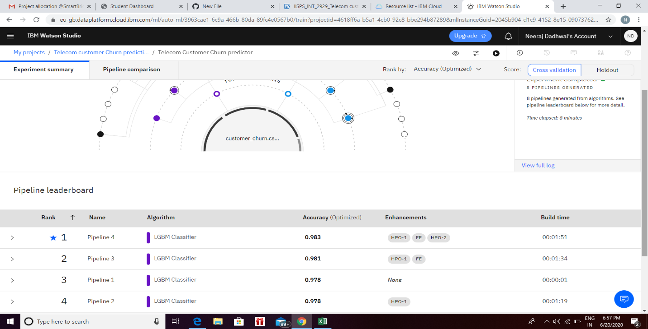

**STEP 4- Deploy and test the model**

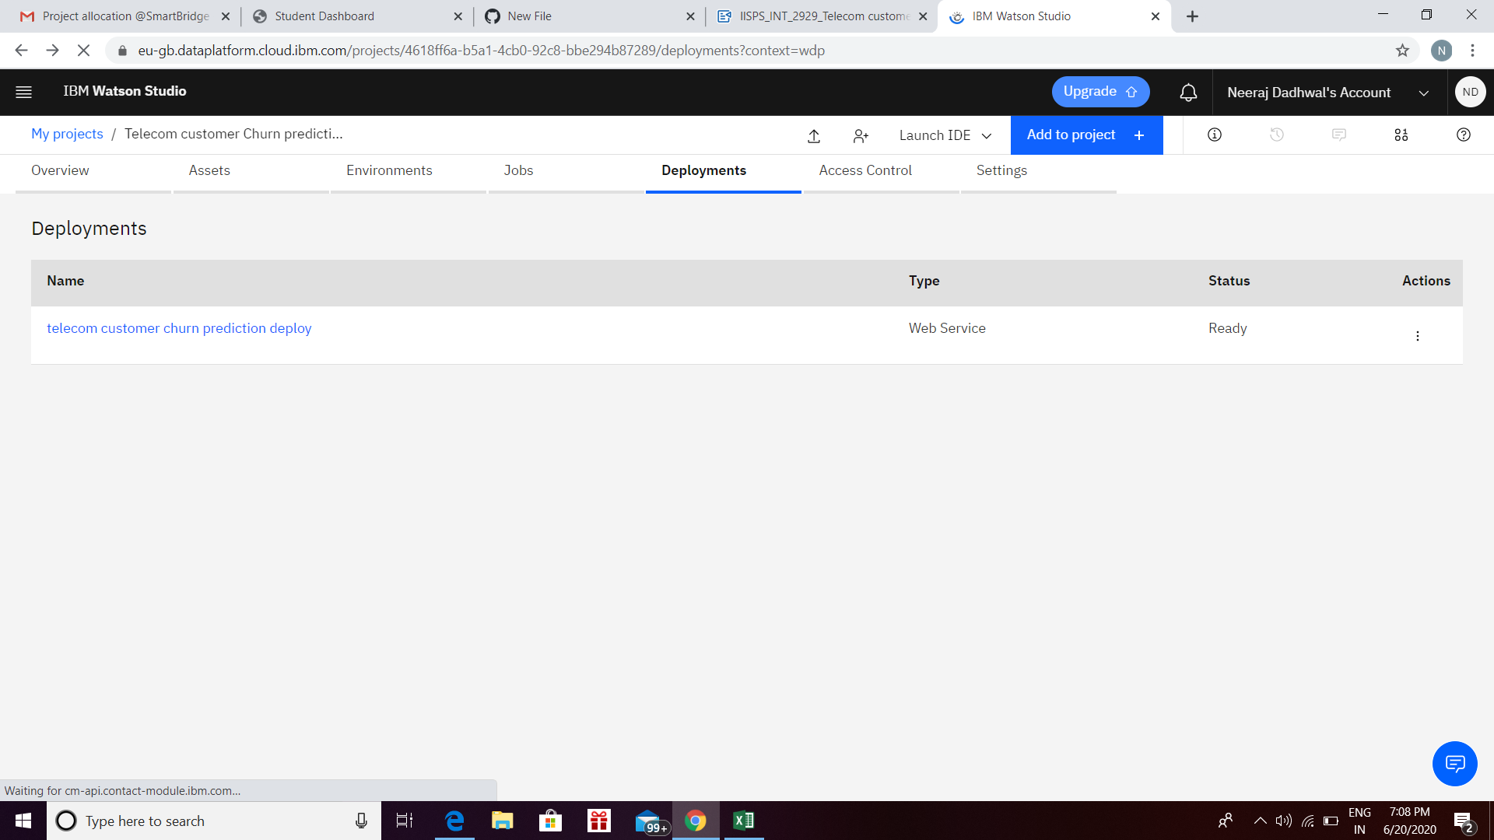

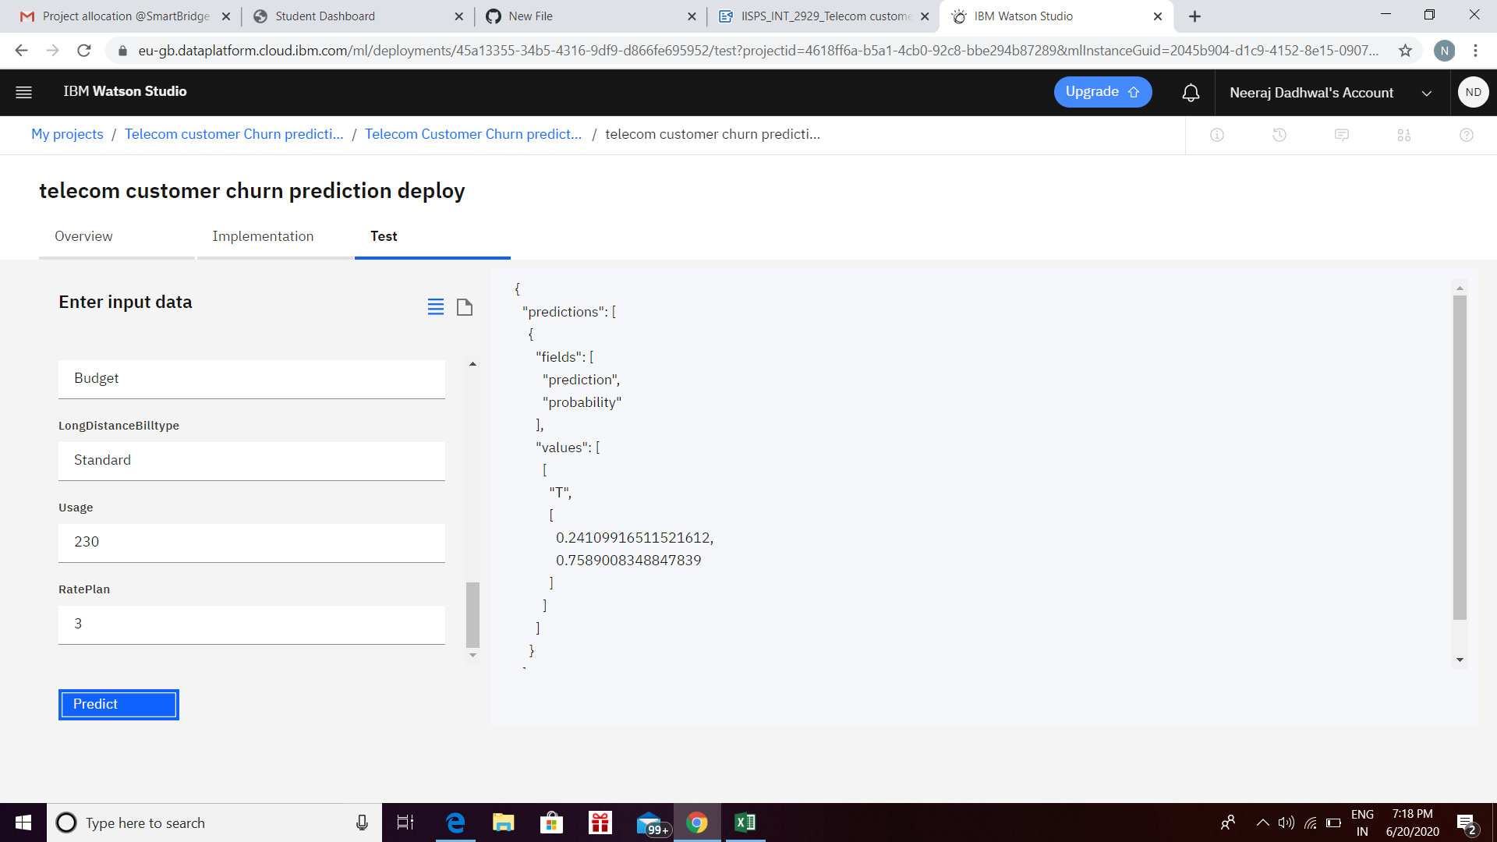

**APPLICATION BUILDING**

**STEP 1- Create node red service**

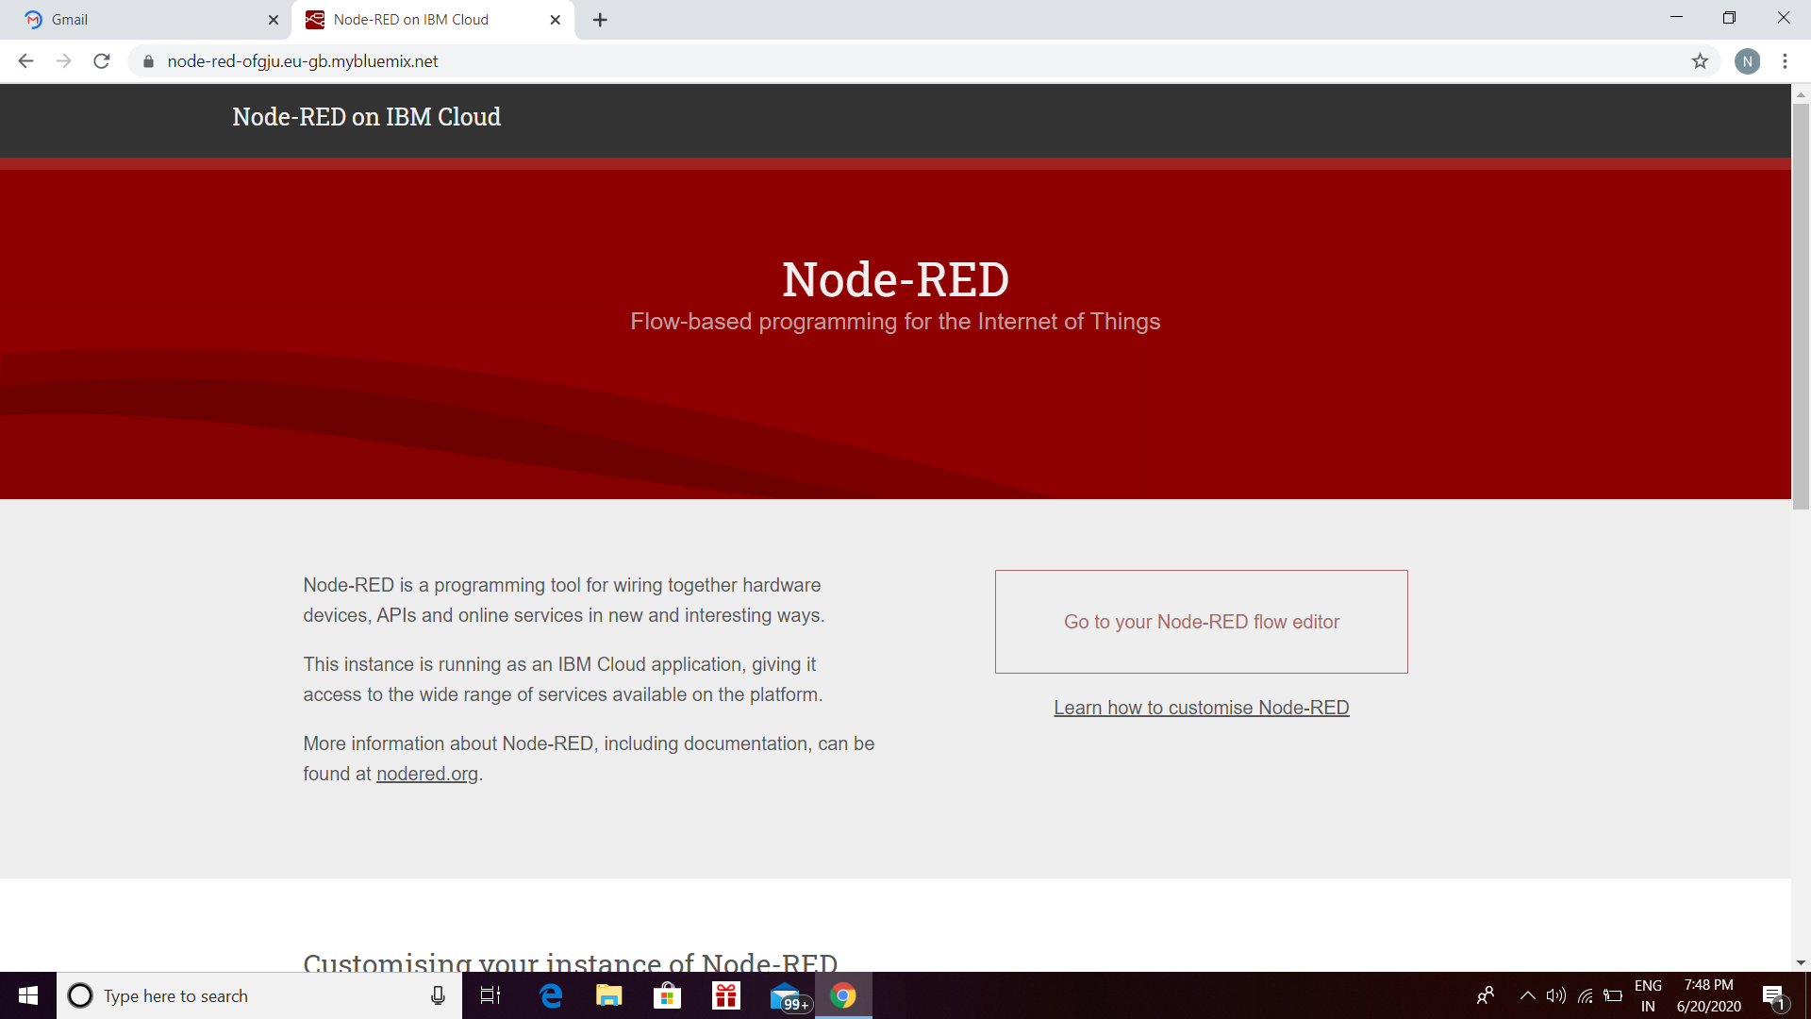

Select the cloud foundry apps and create node red service

**STEP 2 - Use node red editor and import the Json file and make a flow**

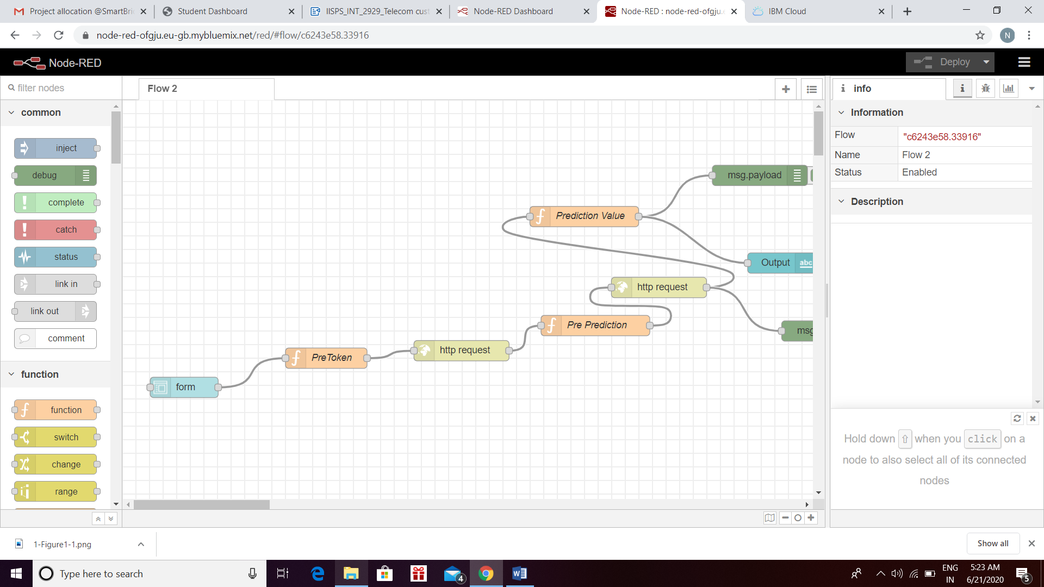

After this flow is made we have to insert the column names , url, api key in the design pallets.

**STEP 3- Deploy the flow and create ui.**

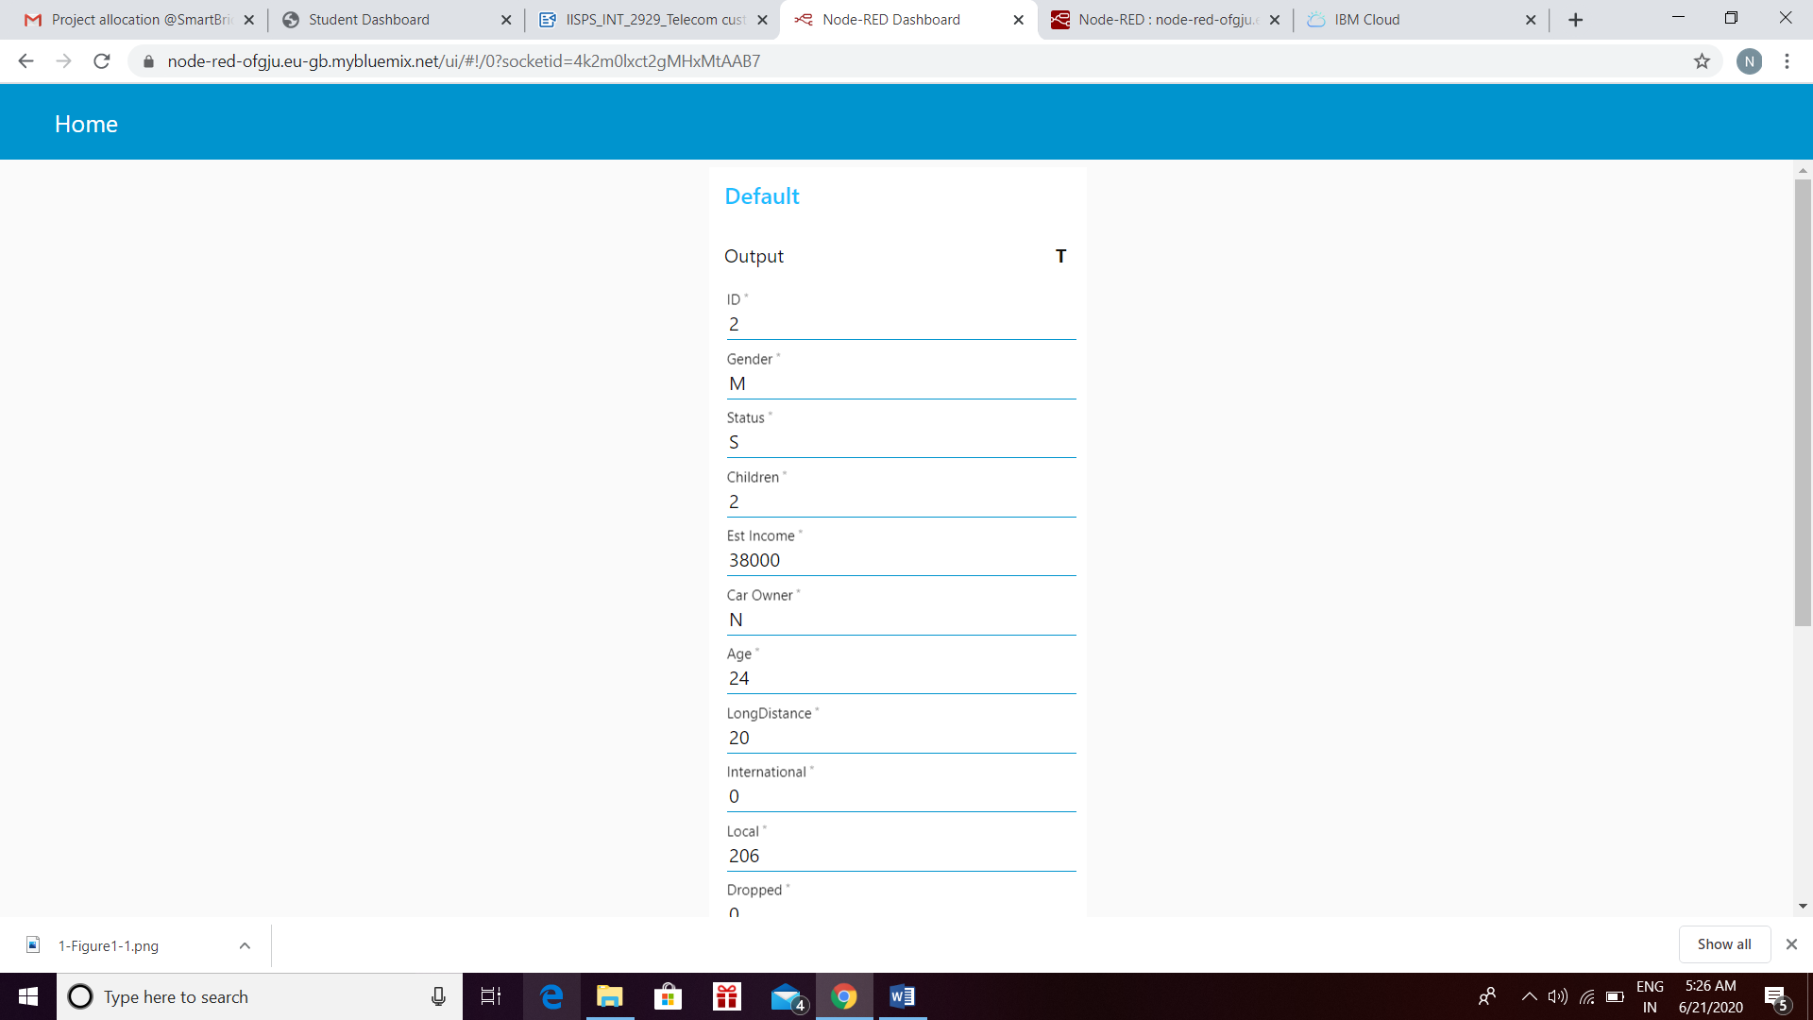

**ADVANTAGES AND DISADVANTAGES**

**This churn analysis solution provided benefits that helped the client to:**

* **Access all the relevant data seamlessly and quickly**
* **Segment the customers based on behavior and demographics to improve retention**
* **Deliver tailored promotions and offers to positively influence their behavior**
* **Minimize acquisition costs and increase marketing efficiency**
* **Keep customers engaged and loyal**

**This churn analysis solution offered predictive insights such as:**

* **Predicting customers overall satisfaction as well as their experience with service quality**
* **Identifying potential network issues, competitive threats, and at-risk customers**
* **Identifying the negative customer experience trends and reducing attrition levels**
* **Building a robust predictive model and gathering data**
* **Creating new opportunities for cross-selling and upselling**

**FUTURE SCOPE**

An intelligent predictive churn analytics model, powered by Big Data analytics will allow businesses to process, analyze, and co-relate traditional and non-traditional metrics to achieve a holistic customer blueprint and effective insights that can trigger an alarm way before real damage is done. A simple example can be that of personalized retention incentives. Businesses can combine the insights from traditional churn analytics models such as average transaction value, monthly discount values, last transaction date, and so on with data from non-traditional sources such as brand or product sentiment on social media, number of complaints in the last month to the call center, competitor offers, and others. They can use this, to predict the churning intent of the said customer and quickly create a customized offer to try and retain them.

Predictive churn analytics is a small step towards automated personalization, which will be a critical business differentiator delivered by full-fledged Big Data adoption. However, businesses will have to start from small use cases, strategizing progressively to encompass complex multi-level use cases to realize the full potential of Big Data analytics. Businesses have to gear up and ensure that they can manage the speed and complexity of Big Data, establish well defined data points, and equip employees with enough training to handle the process complexities. Most importantly, businesses will have to shift the traditional Business Intelligence mindset of reporting and adapt to the real-time action mindset to successfully decipher the holistic customer insights that Big Data analytics is capable of providing.

**BIBLIOGRAPHY**

This project Telecom customer churn predictor is done by me. I have made this under guidance of smartinternz experts. I have taken help of below platforms for succesfully completing the project i.e.

SMARTINTERNZ

IBM CLOUD

IBM WATSON STUDIO

GITHUB

THANK U.